Renju lesson on November 9, 2000

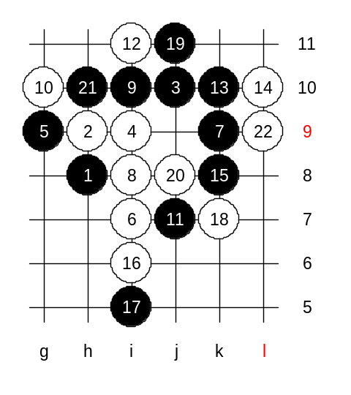
Lets begin the lesson. Last week we finished learning the 5th move to j9. We realized that there are still many open questions. Today's lesson topic is another 5th move. We take a look at 5-g9. We can call it as main 5th move because black advantage here is bigger that in case of any other 5th move. As usually, we will not waste time on old and ineffective variants. We will try to learn most powerful and modern ways for black. Actually, here is only one 6th move that does not lose - 6-i7. Now, some words about 7th move and my evaluations: There are four 7th moves possible here. Who can list them for me? Yes, as finite listed, moves k9, i10, h10, i8 are all possible 7th moves. Moves i10 and i8 are old moves whereas h10 and k9 are quite new moves. 7-h10 was popular 3 years ago whereas 7-k9 was popular 1-2 years ago. 7-i10 and i8 were popular already 10 years ago and still people play them. According to my recent analysis, 7-k9 seems to be the strongest. I can show you some of my analyses here which have not been used in any tournaments yet. White has two choices for 8th move. 8-i8 (active) and 8-i11 (passive). First, I will show my analysis about active i8. Now, there are two main paths for white: 10-h10 and 10-g10. We study g10 first. Black gets very powerful attacking base on the right side. White cannot just continue with simple defense moves because black advantage is too good there already. White has to defend actively in order to keep up the tempo and hope to get some more defense stones in future. Where is that move? Yes, i11. What should black do now? We have to look the situation like this: Can black win with straight attack? As you know, if black cannot win with straight attack then usually any three or four makes black position only worse. But since it is a lesson and not a real game, so lets try about that black attack. If it fails, then we know we should not have attacked. By the 22nd move black attack has failed. Now we know that black should not have attacked at all because of absence of straight win. Lets look what black should have done instead.

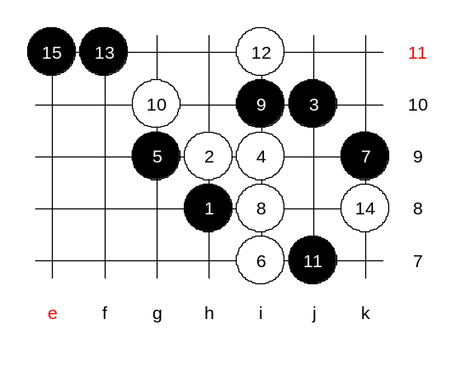
We need to change the 13th move. IF black cannot attack, what should black do then? Black uses 13-f11 to for 3 purposes: 1.Defend white structures, 2. Help black go to attack through j9 and k8 as white is not blocking it in upper side anymore, 3. Prepare future base for black attack on the left side. White has to choose between defending left or right side. According to my analysis, no matter how white plays, black wins on the opposite side. Well, the easiest way is to try and see if it is true. Obviously, the right side looks more scary and white defends there, 14-k8. Move 15-e9 is simple and strong. How to defend here? I have not found any good defense moves here. The result of this position raised new question: what if white plays f11 first and then i11. Lets see.

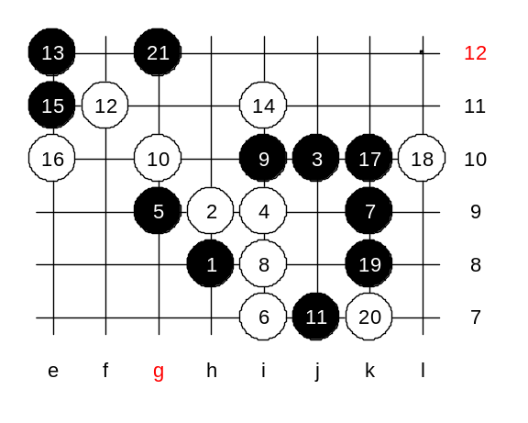
White can control black's straight attack attempt on the right side. If black plays j9 and k8, then white can block it from h11 with a three and black will be in trouble. That means, black position is not ready for straight attack yet. Black has to take care of that possible white three already before beginning the attack. Move 15-e11 kills white line that was defending black straight attack j9, k8. Besides, e11 also creates black attacking base on the left side. Now, white has same problem as on previous position - how to defend both sides? What should white do now? Lets try e10 then. Black win is quite simple here.

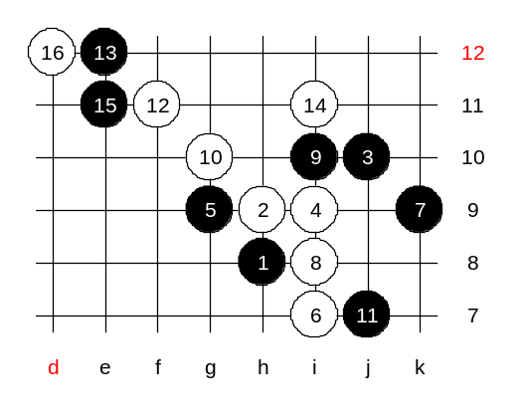
Let’s test some other 16th moves too. Lets see what can black do in case of passive 16th move to d12. Let’s do this way. The position that you see on the screen now, this is the advanced level homework. Please write it down right now. Your homework is to find black win here.

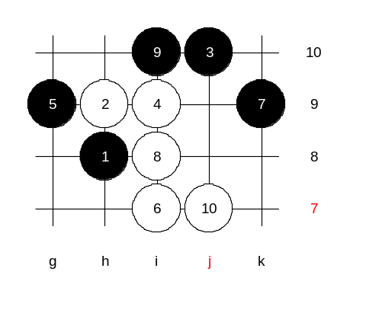
If it is already time for homework then lets show the medium level homework too. Last week medium homework was difficult, this week will be easy. Please find the black win here. I announce the renju class to be finished here. Those who leave now, I wish good day and see you next week! :)

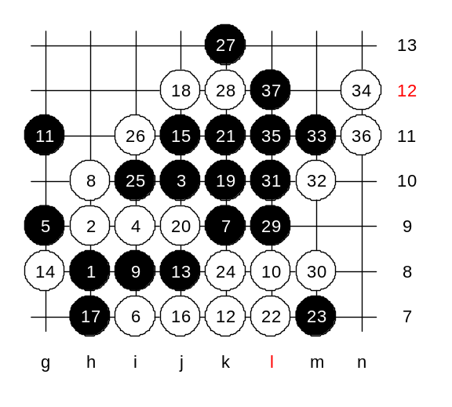
Lets play the test game students vs teacher. I give you chance to be black. You have to vote for each move. The move that gets the most number of votes will be played. Lu, you count the votes. It seem the gambling 8th move is getting teacher into trouble. :)
Good game!
Some comments:
We did not study this 8th move during lesson. The reason is the same thing that happened in this game, with 9-i8 black gets winning position. Any 10th move seems to lose here.
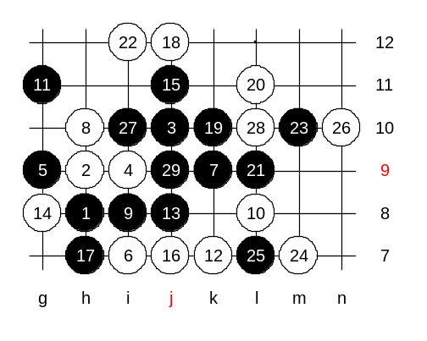

Lets see what happens if 20-L11.

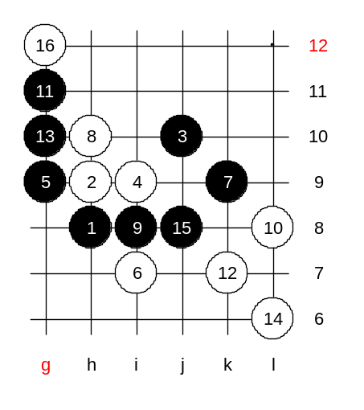
Lets see what would have happened if you had chosen g10 instead of j8. After the 16th move it is not easy to decide what black should do. Therefore, I congratulate you for choosing wisely j8 instead of g10! Whoever voted for j8 in that critical moment, he made the key move. Time to get some rest now, thanks for game, and good night all! :)

